**East West University**

**Lab Report**

**Semester:** Fall-2024

**Course Title:** Electronic Circuits **Course Code:** CSE251

**Sec:** 03

**Expt No: 03**

**Expt Name: Study of Zener Diode.**

**Group No: 07**

**Submitted by-**

**Name: Sheikh Sarafat Hossain**

**Id: 2022-3-60-109**

**Submitted to-**

**Dr. Sarwar Jahan**

**Associate Professor**

Department of Computer Science & Engineering

East West University

**Date of Performance: 14-11-2024**

**Date of Submission: 27-11-2024**

**Title: S****tudy of Zener Diode.**

**Objectives:**

1. To measure the I-V characteristic of Zener diode.
2. To determine the voltage regulation for variable resistance and variable supply voltage.

**Introduction:**

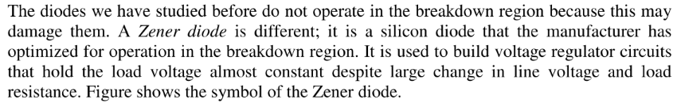

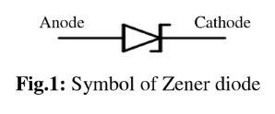

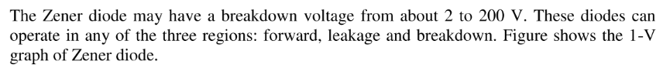

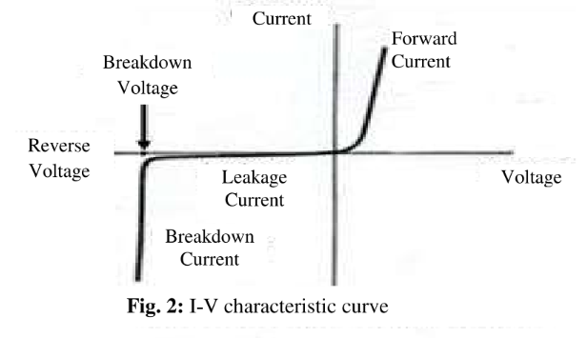

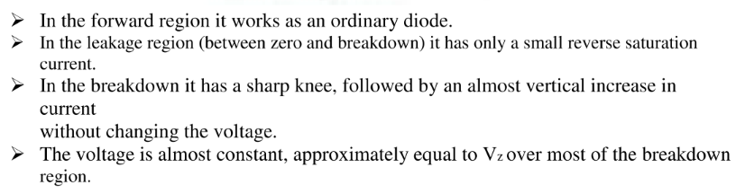

**Approximation:**

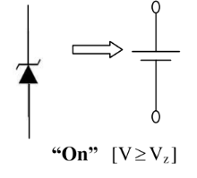 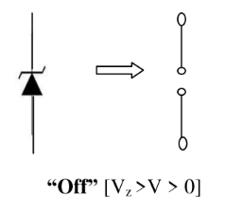

**Circuit diagram:**

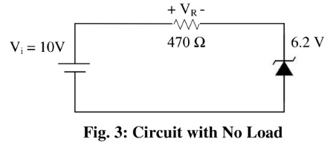 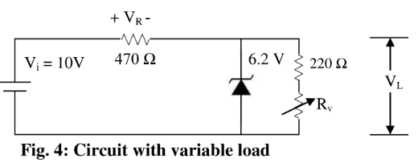

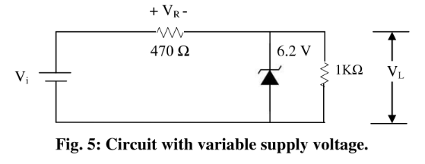

**Answers to the Pre-Lab Questions**

**1.** Applying KVL in Fig-3,

We find, I = 34.468 mA

VZ = V = 6.2 V

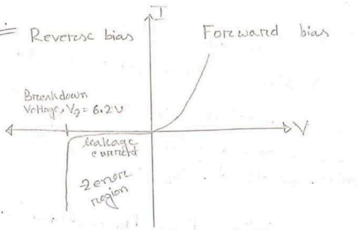

Fig : I-V characteristic

**2.** Given,

Vi = 10 V

R = 470 Ω = 0.47 KΩ

From fig-5, RL = 1KΩ

So, VL = Vi×RL / R+RL

= (10×1 / 0.47+1) V

= 6.802V

Now, IR =IL= Vi / R+RL

= 6.802mA

So, VR = IR×R=6.802×0.47V

= 3.198V

IZ= IR – IL = 0mA

**3.** To determine the condition for conduction in a circuit where RL=220 Ω, you need more context about the type of circuit (e.g., diode, transistor, etc.) and the elements involved. However, a general approach can be described for some common cases:

### **1. Diode Circuit**

* For a diode to conduct:

Vin≥Vthreshold+I⋅RL

Where Vthreshold​ is the forward voltage drop of the diode (typically 0.7 V for silicon diodes or 0.3 V for germanium diodes).

### 2**. Transistor Circuit (NPN or PNP)**

* For a transistor to conduct (in active mode):
  + - NPN transistor: Base-emitter voltage VBE ≥ 0.7V (for silicon).
    - The base current IB must be sufficient to satisfy: IB=IC / Iβ
    - where IC is the collector current and β is the current gain of the transistor.

### 3. **General Resistive Load**

* For a resistive load RL=220 Ω, conduction occurs when:

Vin ≥ I⋅RL , ​ where I is the current through the load.

**4.** From Fig-4,

Vi = 10V

VZ = V = 6.2V [For open Zener diode]

R = 0.47KΩ

RLmin = V×R / Vi – V

= 0.7668 KΩ

Now, VR = Vi – VZ = 10 – 6.2 = 3.8V

So, ILmax = V / RLmin = 6.2 / 0.7668 mA

= 8.085 mA

IR = VR /R = 3.8 / 0.47 = 8.085 mA

Applying KCL at node A,

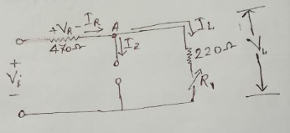

IR = IZmax + ILmin

=>ILmin = 8.085 – 7.2 = 0.885 mA

RLmax = VZ / ILmin = 6.2 / 0.885 = 7.00 KΩ

**5.** From Fig-5,

Vi = 10V

VZ = V = 6.2V [For open Zener diode]

R = 0.47KΩ

RL = 1KΩ

We know,

Vimin = V(RL + R) / RL

= 19.39 V

IL = VL /RL = 4.44/1 = 4.44 mA

IRmax = IZmax + IL = 7.2 + 4.44 = 11.64KΩ

So, Vimax = (IRmax×R) + VZ = (11.64×0.47) + 6.2 V

= 11.670

**Equipments:**

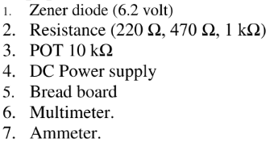

**Procedure:** 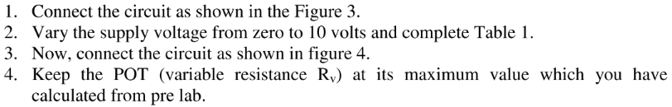 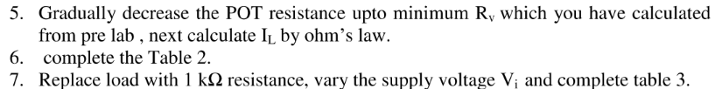

**Experimental Data-Sheet:**

**Table 1:** Data for I-V characteristics

|  |  |  |  |
| --- | --- | --- | --- |
| Vi (Volt) | VR (volt) | Vz (volt) | Iz = VR / R |
| 1 | 0 | 0.89 | 0 |
| 2 | 0.0077 | 1.88 | 0.016 |
| 3 | 0.16 | 2.76 | 0.344 |
| 4 | 0.63 | 3.35 | 1.357 |
| 5 | 1.28 | 3.66 | 2.758 |
| 6 | 2.11 | 3.87 | 4.547 |
| 7 | 2.91 | 4.00 | 6.271 |
| 8 | 3.88 | 4.11 | 8.362 |
| 9 | 4.77 | 4.19 | 10.28 |
| 10 | 5.74 | 4.25 | 12.37 |

**Table 2:** Data for regulation due to load variation

|  |  |  |
| --- | --- | --- |
| Vi (Volt) | VL (Volt) | IL (Amp) |
| 10V | 4.44V | 0.47 |
| 0.619 |
| 0.67 |
| 1 |
| 1.809 |
| 3.14 |
| 5 |
| 15.76 |
| 16 |
| 16.095 |

**Table 3:** Data for regulation due to supply voltage variation

|  |  |
| --- | --- |
| Vi (Volt) | VL (Volt) |
| 1 | 0.68 |
| 2 | 1.40 |
| 3 | 2.09 |
| 4 | 2.77 |
| 5 | 3.31 |
| 6 | 3.66 |
| 7 | 3.92 |
| 8 | 4.19 |
| 9 | 4.33 |
| 10 | 4.43 |

**Answers to the Post-Lab Questions**

**1.**

From plot, Zener breakdown voltage is 2.75.

**2.**

From the graph, the load regulation is 16 mA to 16.295 mA because in this region the load voltage is constant. But from the pre lab data we get, the load regulation is 213mA (Imin) to 417.9mA (Imax)

**3.** 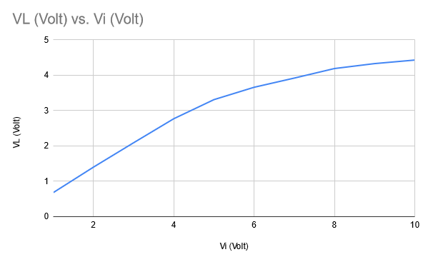

From the graph, the line regulation is 5V to 10V because the load voltages are almost constant in this region.

**Discussion:**

